# CS 255 System Design Document Template

## UML Diagrams

### UML Use Case Diagram

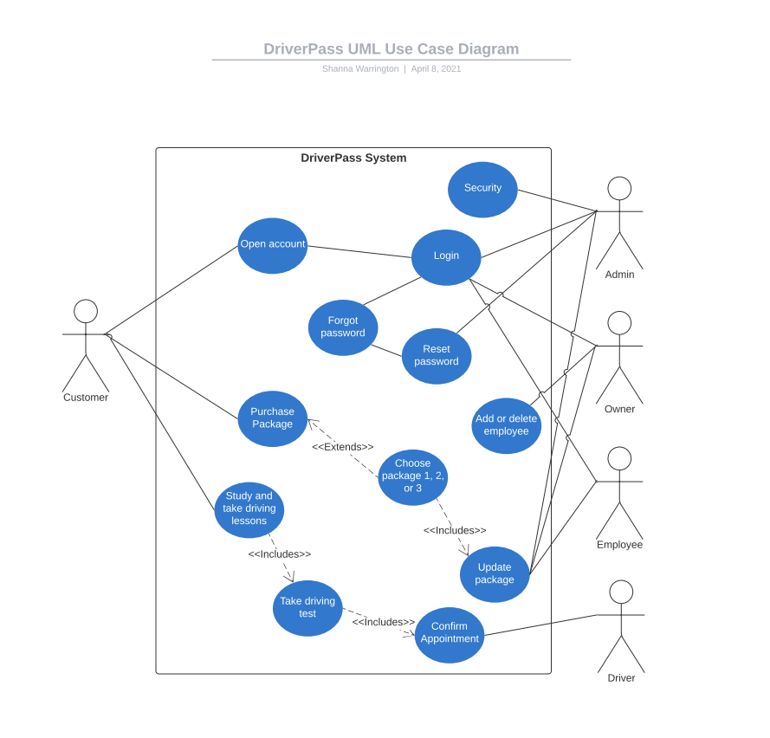

### UML Activity Diagrams

### UML Sequence Diagram

### UML Class Diagram

## Technical Requirements

The technical requirements needed for the system will be a computer, tablet, or mobile device that has access to the internet. The device will need to be able to connect to Wi-Fi or have available data in the case of a phone or tablet.